# **Introduction to Hand by hand**

The unique advantage of Hand by Hand: providing one-stop services for children's comprehensive development

Hand by hand has unique advantages in the fields of education and training, which are highlighted through the following ways, providing strong support and convenience for children's comprehensive development:

## Comprehensive development：

Hand by hand is dedicated to offering children a holistic education and training that spans multiple fields. Children can access a broader spectrum of learning opportunities within the same institution, facilitating their comprehensive development in various areas.

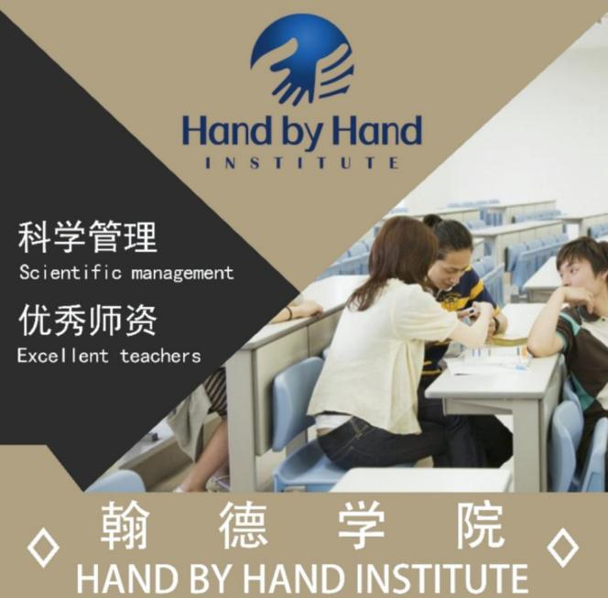

## One stop service:

By integrating various courses, we offer parents a one-stop service. Instead of spreading out across multiple locations, parents can now fulfill all their child's learning needs within the same institution, significantly reducing their time and effort.

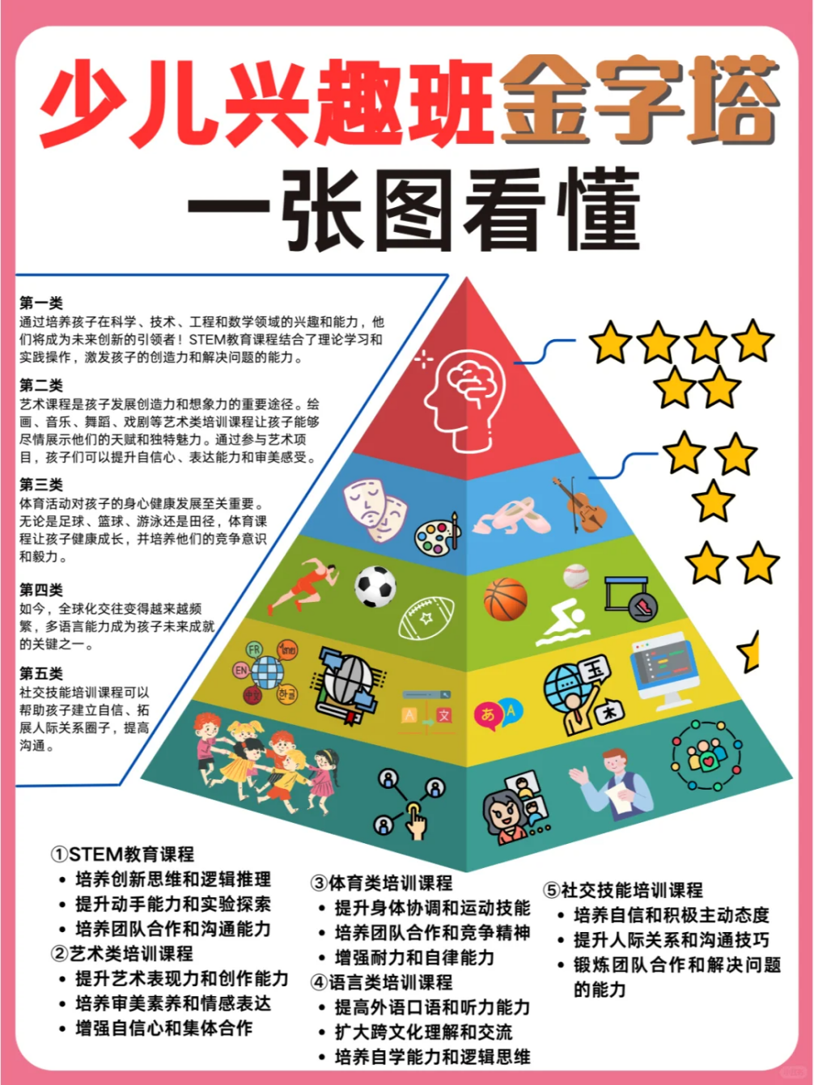

## Interdisciplinary learning：

Hand by hand promotes interdisciplinary learning, which is the core concept of Hand by hand. Through the cross integration of different courses, children can broaden their horizons, cultivate comprehensive thinking and innovative abilities, and lay a solid foundation for future learning and career development.

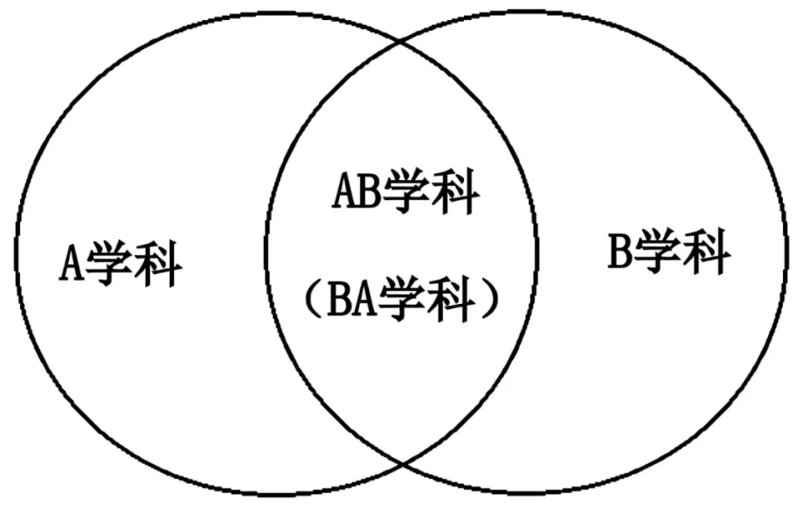

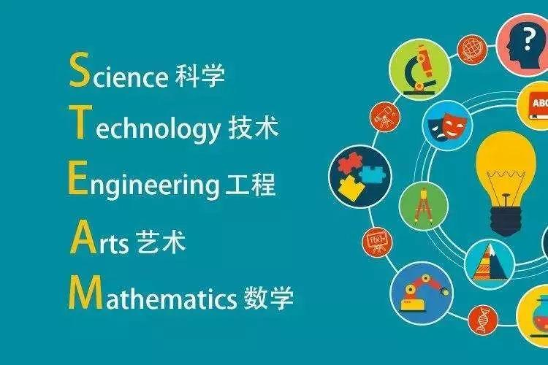

## Excellent faculty team:

Hand by hand has an excellent faculty team. These teachers have interdisciplinary teaching experience and professional knowledge, which can provide high-quality education and guidance for children. Our goal is to ensure that they receive good learning support.

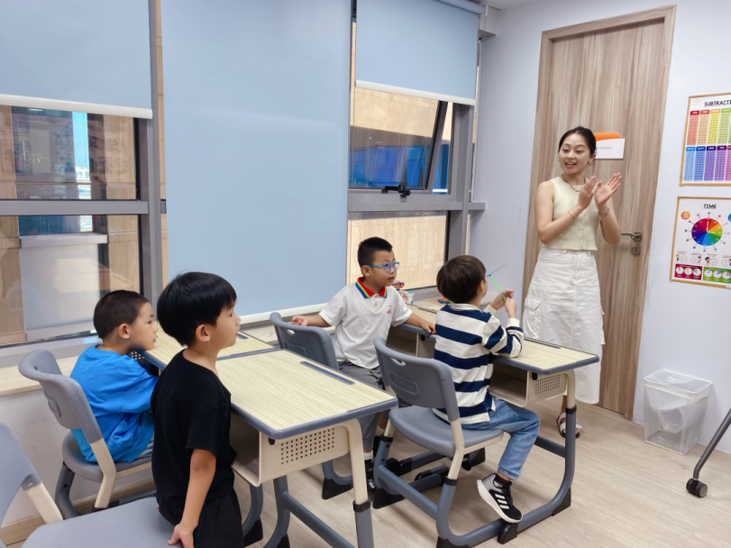

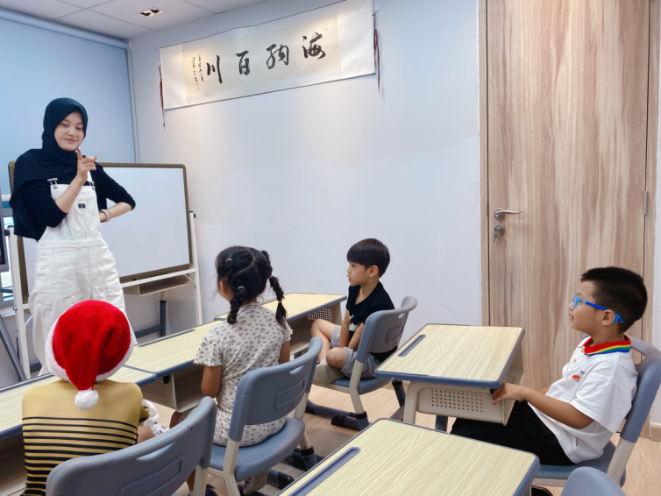

## Personalized tutoring：

Hand by hand provides personalized tutoring and guidance based on the child's interests and abilities. This personalized learning approach can help children achieve more comprehensive learning goals and fully unleash their potential.

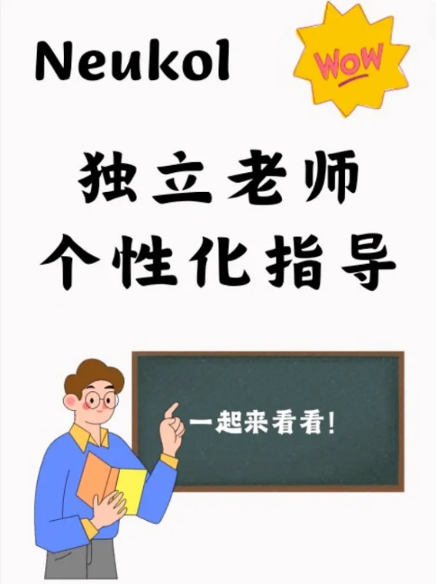

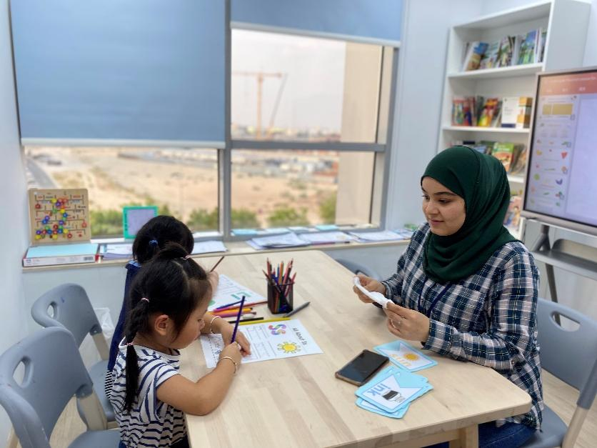

## Social interaction：

Hand by hand also emphasizes the importance of social interaction. Students from different backgrounds and fields of interest gather here, providing them with a wider range of social interaction opportunities, helping them establish interpersonal relationships and expand their networks. These factors contribute to the comprehensive development of children.

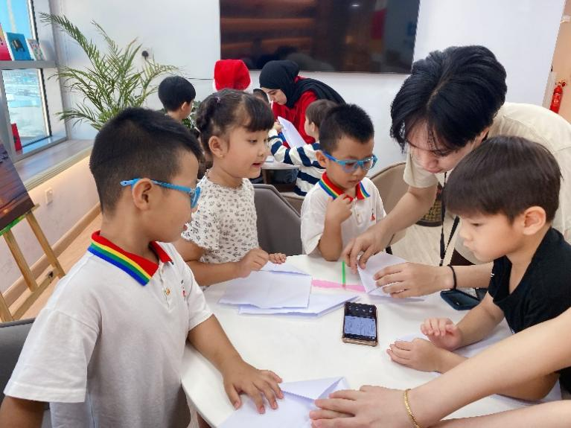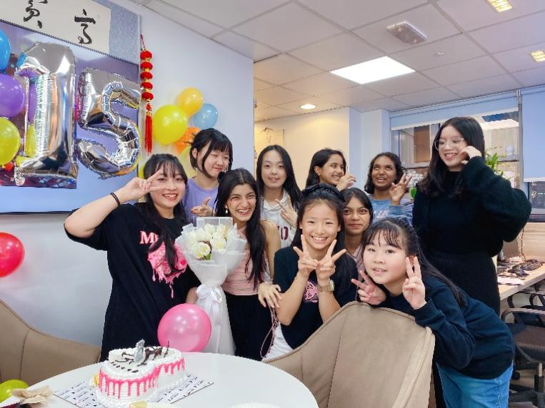

## extracurricular activities：

The various activities organized by Hand are very diverse, such as competitions, performances, exhibitions, etc. These activities can not only stimulate children's interest and creativity, but also exercise their leadership skills and teamwork spirit.



## resource sharing：

Hand by hand usually has abundant teaching resources and facilities, such as libraries, laboratories, art studios, etc. Children can fully utilize these resources for learning and exploration, enhancing their learning outcomes and experiences.

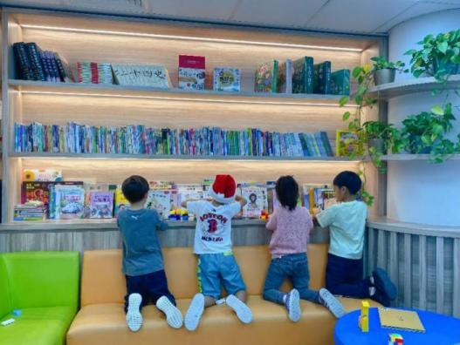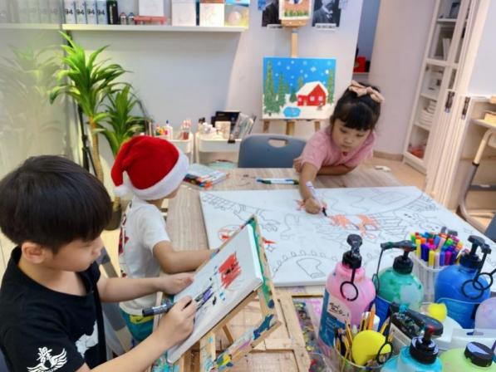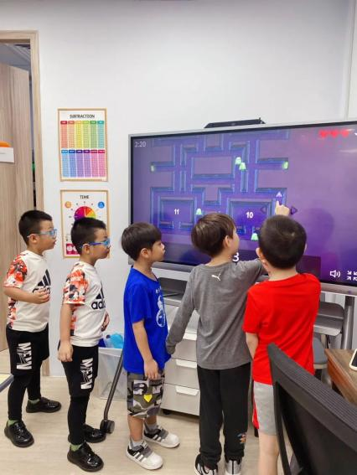

## Lifelong learning：

Hand by hand focuses on cultivating students' lifelong learning abilities. The courses and activities they provide not only meet the current learning needs of children, but also lay a solid foundation for their future development, cultivating their lifelong learning habits and awareness.

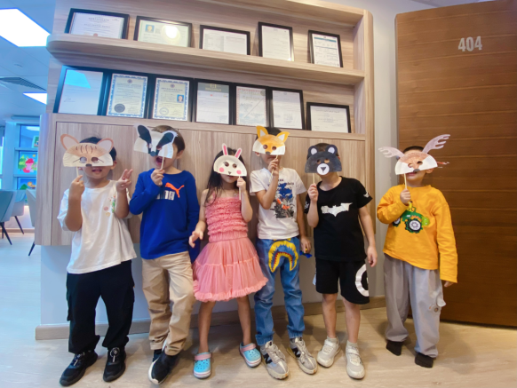

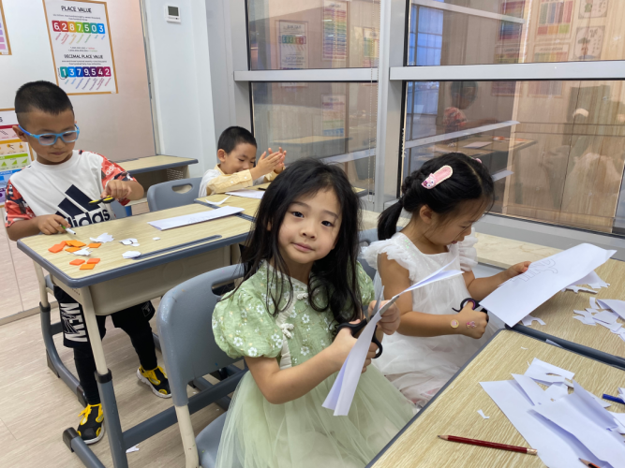

## Brand reputation：

Hand by hand, having a good brand reputation and successful cases can increase parents' trust and willingness to make choices. Parents can confidently choose to provide high-quality education and training services for their children.



## Scientific data-driven management：

Hand by hand adopts scientific management, which will further upgrade the current management system. Students and parents can have a more intuitive understanding of the current class situation and the stage growth process of students through our online management system. Parents can also share their family education experience through our platform, and can buy and sell idle items on the platform to create value.

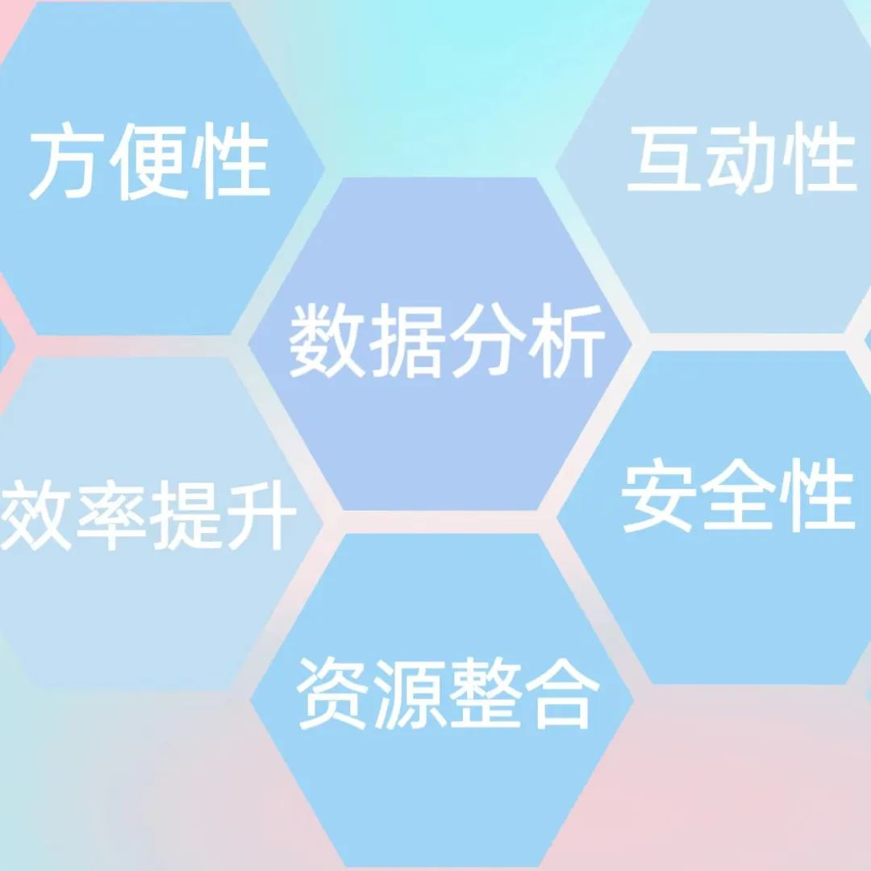

1. Convenience: Students, teachers and administrators can access the system via the Internet at any time and anywhere without being limited to specific time and place.

2. Efficiency improvement: The system can automate tasks such as course scheduling, student management, and exam score recording, reducing tedious manual work and improving work efficiency.

3. Resource integration: Through an online management system, you can centrally manage course materials, teaching resources, student files, and other information, making it easy to manage and share them uniformly.

4. Data analysis: The system can generate detailed data reports and analyses to help you understand students' learning progress, teaching effectiveness, and other situations, providing a basis for decision-making.

5. Interactivity: The system provides functions such as online discussion, homework submission, and real-time feedback, promoting interaction and communication between students and teachers.

6. Security: Ensure the protection of sensitive information and personal privacy in the system through measures such as permission management and data encryption.

Hand by hand, by highlighting the above advantages, attracts the attention of parents and provides strong reasons for them to choose Hand by hand to meet their children's educational and training needs. These advantages include comprehensive development, one-stop service, interdisciplinary learning, personalized tutoring, excellent teaching team, social interaction, extracurricular activities, resource sharing, lifelong learning, brand reputation, and scientific data management. Hand by hand provides children with more learning opportunities and convenience, cultivating their comprehensive abilities, innovative spirit, and social skills, laying a solid foundation for their future development. Parents can trust Hand by Hand to help them achieve personal growth and success.

# Hand by Hand

# Activity Introduction

# Winter Camp Activities

## First week



Full time Comprehensive Literacy Course from Monday to Thursday

Including Chinese, picture book reading, Arabic basics, mathematical thinking, English, art creation, LEGO classes, dance classes, group activities... Cultivate children's independence, interest enlightenment, stimulate hobbies, and exercise their teamwork spirit

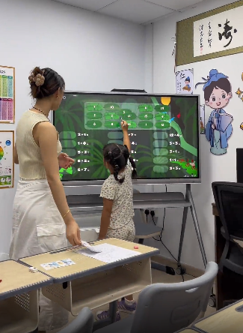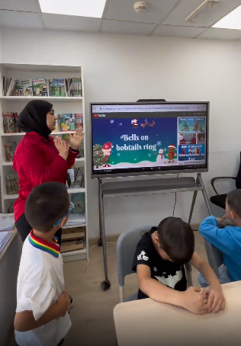

Friday off campus theme park exploration activity

《MOE Ski Resort》

Activity content

On Friday at 09:30, the tourist bus will arrive downstairs at Hand by hand and wait for boarding. It will depart at 9:45 for MOE Dubai Ski Resort and arrive at 10:15 to collect tickets and change ski equipment. Children can play to their heart's content from 11:00 to 14:30. It will depart at 15:00 and return to Silicon Valley at 15:30.

target

The purpose of this course is to cultivate children's teamwork spirit, enhance their sports skills, promote the development of outdoor exploration awareness and adventure spirit, truly experience winter, enhance children's physical fitness, cultivate their awareness of respecting and protecting the natural environment, and stimulate their courage and adaptability when facing challenges. Through skiing activities, we also hope to promote children's emotional development, cultivate a positive and optimistic attitude, and develop the perseverance to overcome difficulties.

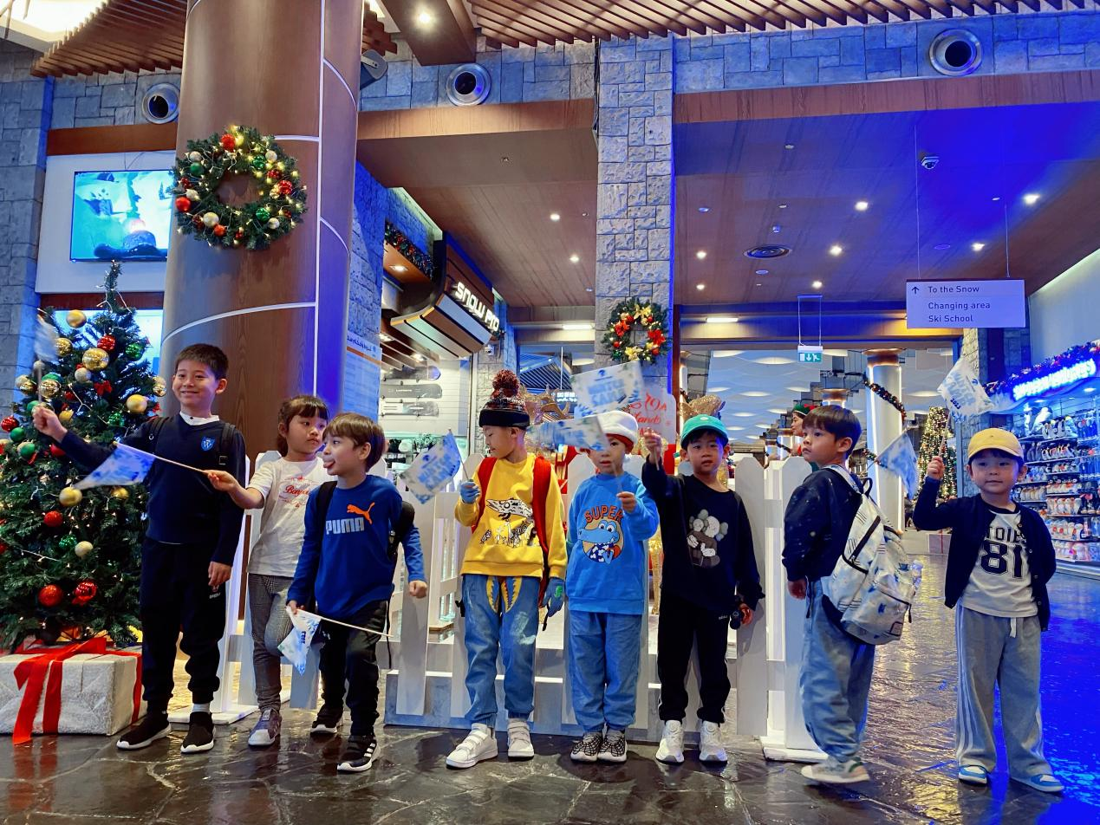

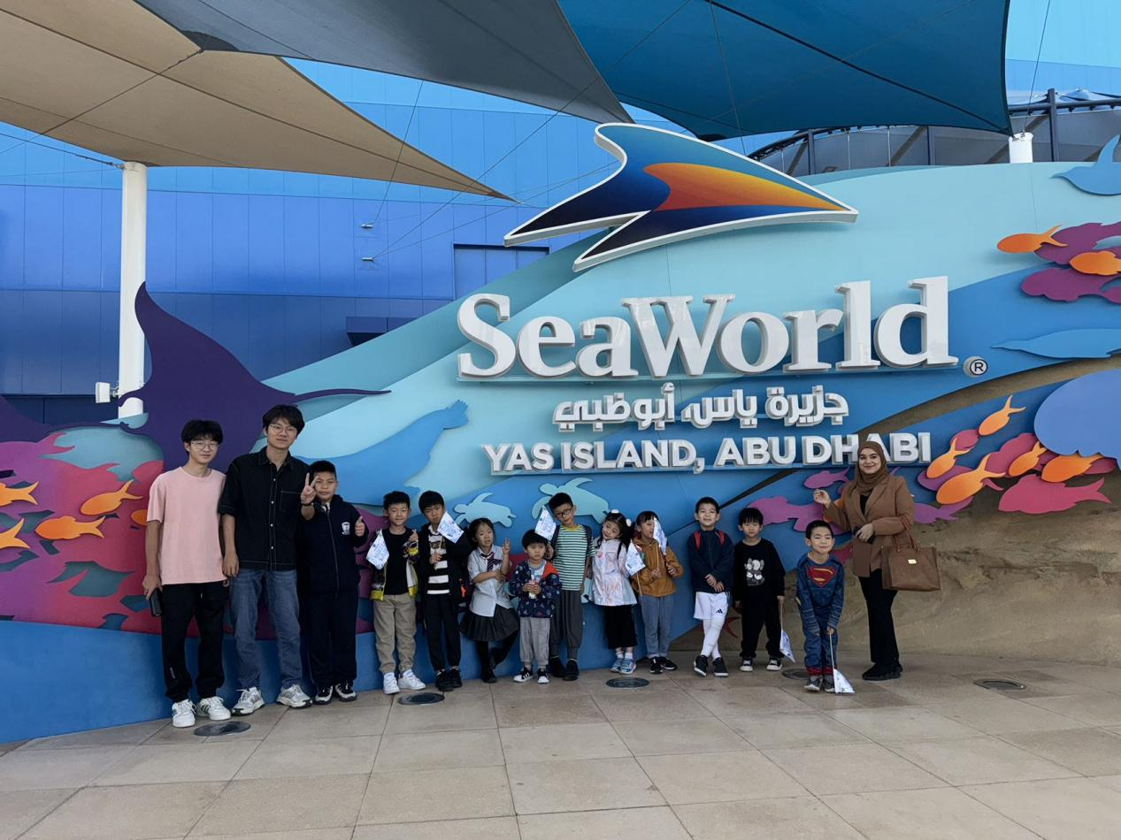

## Safari Park Tour for the Second Week of 2023 Winter Camp

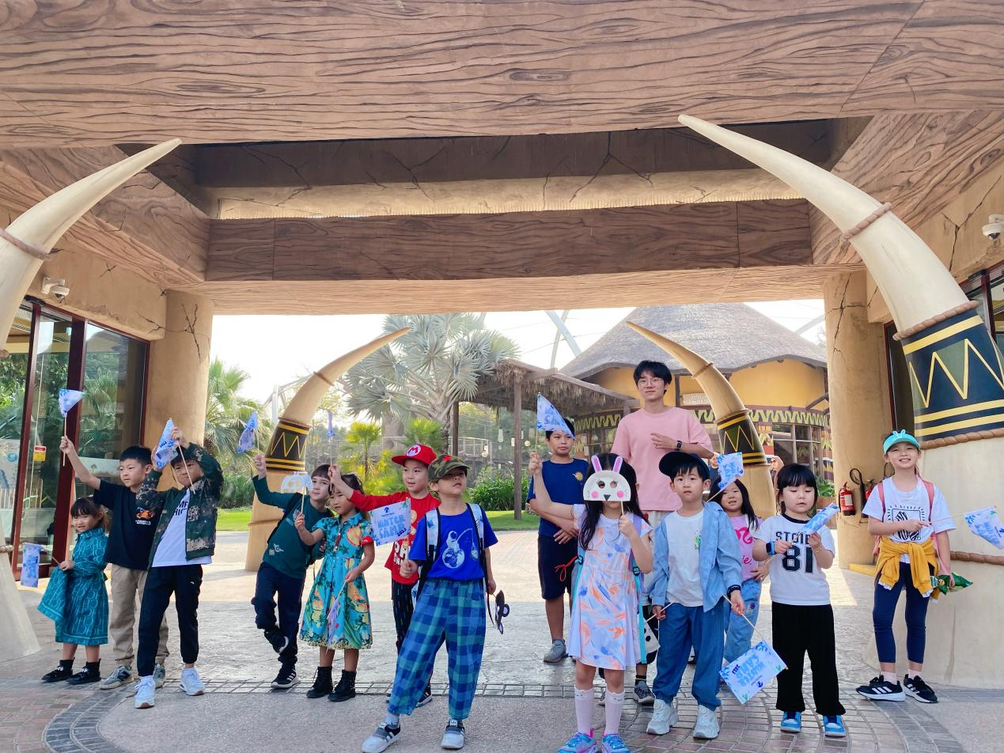

The significance of Dubai Safari Park activities

1. Wide field of vision: Zoo is a great educational venue that can help children understand the ecological habits, morphological characteristics, and other knowledge of various animals.

2. Explore nature: In the zoo, children can have firsthand contact and observe various animals and plants, better understanding and exploring nature.

3. Increase interest: Children's curiosity and interest in animals are innate, and visiting the zoo can further stimulate their interest and enthusiasm for learning.

4. Exercise: Children can walk and run in the zoo, which not only exercises their physical strength but also allows them to experience the beauty of nature.

5. Increase parent-child interaction: Taking children to the zoo is a great parent-child activity that can bring them closer and enhance communication and interaction between parents and children.

6. Understanding animals: By directly observing animals, children can have a more intuitive understanding of their habits, living environment, and relationship with humans.

7. Inspiring observation ability: Observing animals can help children discover the differences between animals in books and in reality, improve their observation ability and respect for nature.

8. Understanding the relationship between nature and humans: Through animals, children can better understand the relationship between nature and humans, as well as the impact of human activities on the environment.

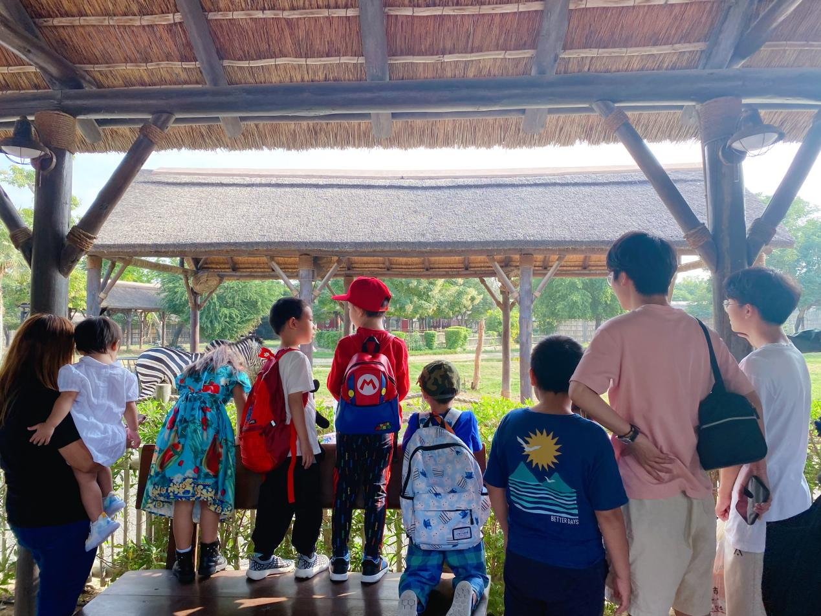

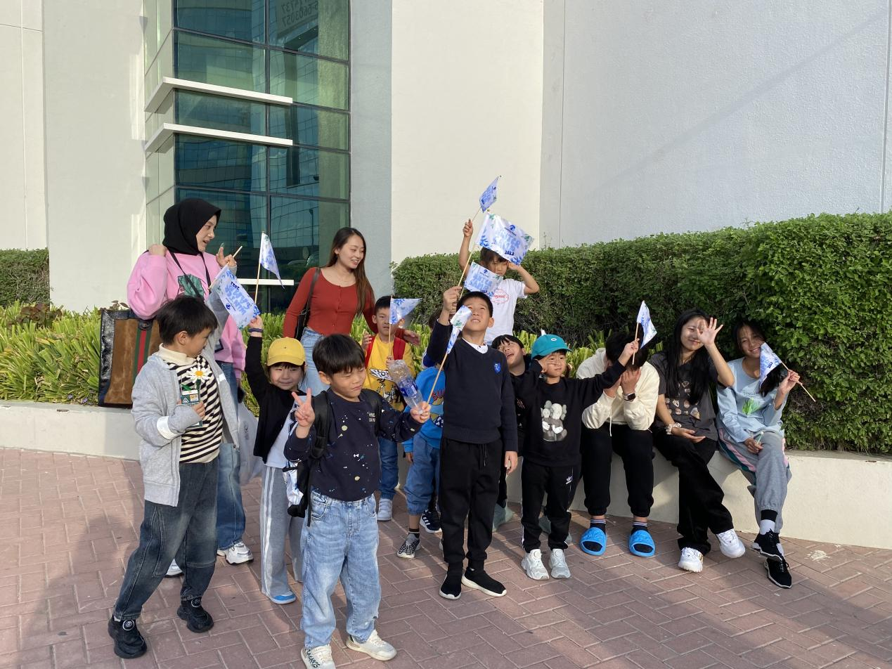

# Hand by hand “Peace and Love”美术展览

# IMG_256

EVENT THEME:

“PEACE AND LOVE”

This event aims to foster community unity, spreading the principles of peace and love. It seeks to raise awareness about the significance of shared experiences and understanding. Through interaction and collaboration, we hope to inspire goodwill, creating a warm and caring environment to lay the foundation for building a more harmonious society in the future.

EVENT ITEMS:

1）14:00

Guest admission, art exhibition, material donation

2）15:00-15:15

Host opening, teacher team introduction, activity introduction

3）15:20-16:20

A performance from T.n Dance Studio

4）16:30-17:00

T.nt performers group photo, intermission, charity auction of art works, Chairman's New Year speech

5）17:20-20:30

Kpop Dance Competition (KDCU)

6）20:30-21:30

Kpop random dance performance

7）21:30

Award ceremony, group photo,  Activity end